BioPhys 3G03 – Assignment 1 – Jatin Chowdhary – January 22th 2022

Question 1)

Density (For When r=0.2)
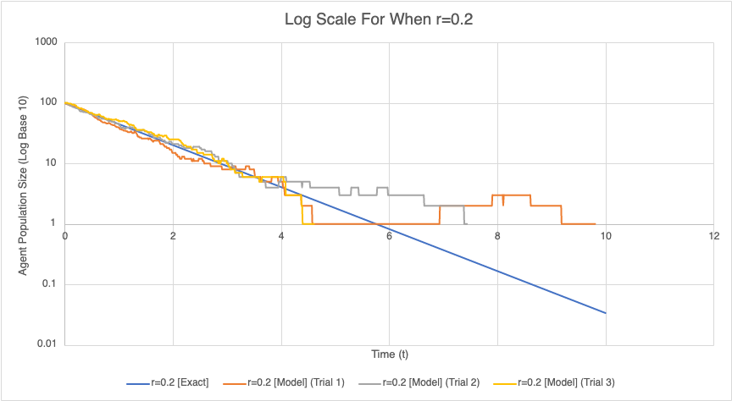Figure 1: This graph represents the agent population for when r=0.2. In total, 3 trials are plotted on the graph in a logarithmic style.

Density (For When r=0.2)
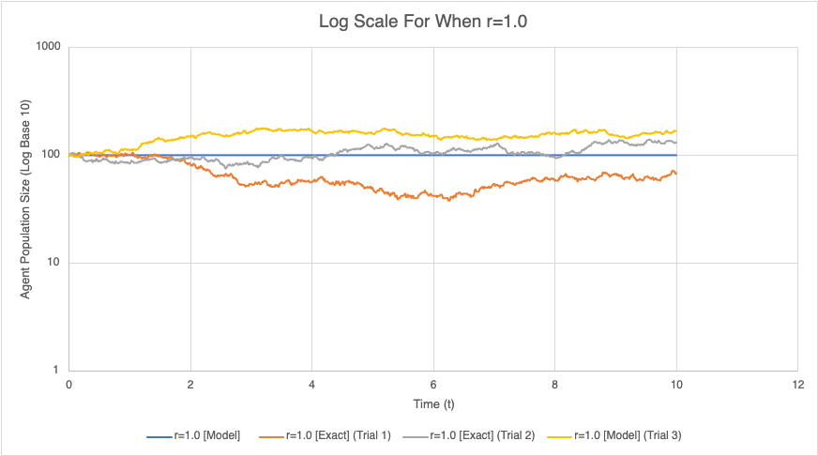Figure 2: This graph represents the agent population for when r=1.0. In total, 3 trials are plotted on the graph in a logarithmic style.

Density (For When r=0.2)
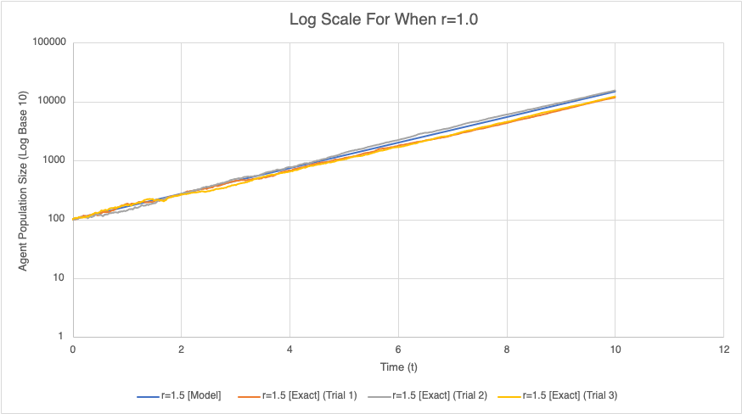Figure 3: This graph represents the agent population for when r=1.5. In total, 3 trials are plotted on the graph in a logarithmic style.

Comment on these results and explain why the three runs for each value of r are slightly different.

The three runs for each value of "r" are slightly different due to a variety of factors. The most profound factor that leads to the variation in each trial run is due to the random-float function. This function generates a random value from 0 to "x", where "x" is the upper bounds of the random number, inclusive. Even though results for this function are evenly/normally distributed, the intermediate output can extremely vary. For example, the trial runs for the log scale for when r=1.0 is not a straight line. Even though the exact lines are close to the model, there is lots of variation; some trials are above the model line and some trials are below the model line. This can be explained due to the nature of the random-float function. Simply put, this function is not true random - rather, it is pseudo-random. Hence, even when the "r" value is 1.0, the agent population can dip below 100 or exceed 100. The random-float function may generate multiple values that cause multiple agents (i.e. Cells) to die in succession. Likewise, the random-float function can generate values which causes multiple agents (i.e. Cells) to hatch in succession (i.e. One after another). Furthermore, the random-float function generates different values each time it is executed. Hence, each trial will have a different line/curve. Nonetheless, the end result is still the same for each value of "r". If "r" is equal to 0, then the trials eventually converge or reach the model line. If "r" is less than 1.0, then the agent population dies out (eventually). If "r' is greater than 1.0, then the agent population increases in the upward direction.

Question 2)
Dr. Higgs went over this in lecture. I will be refering to his notes for the answer to this question. I give full credit to Dr. Higgs.
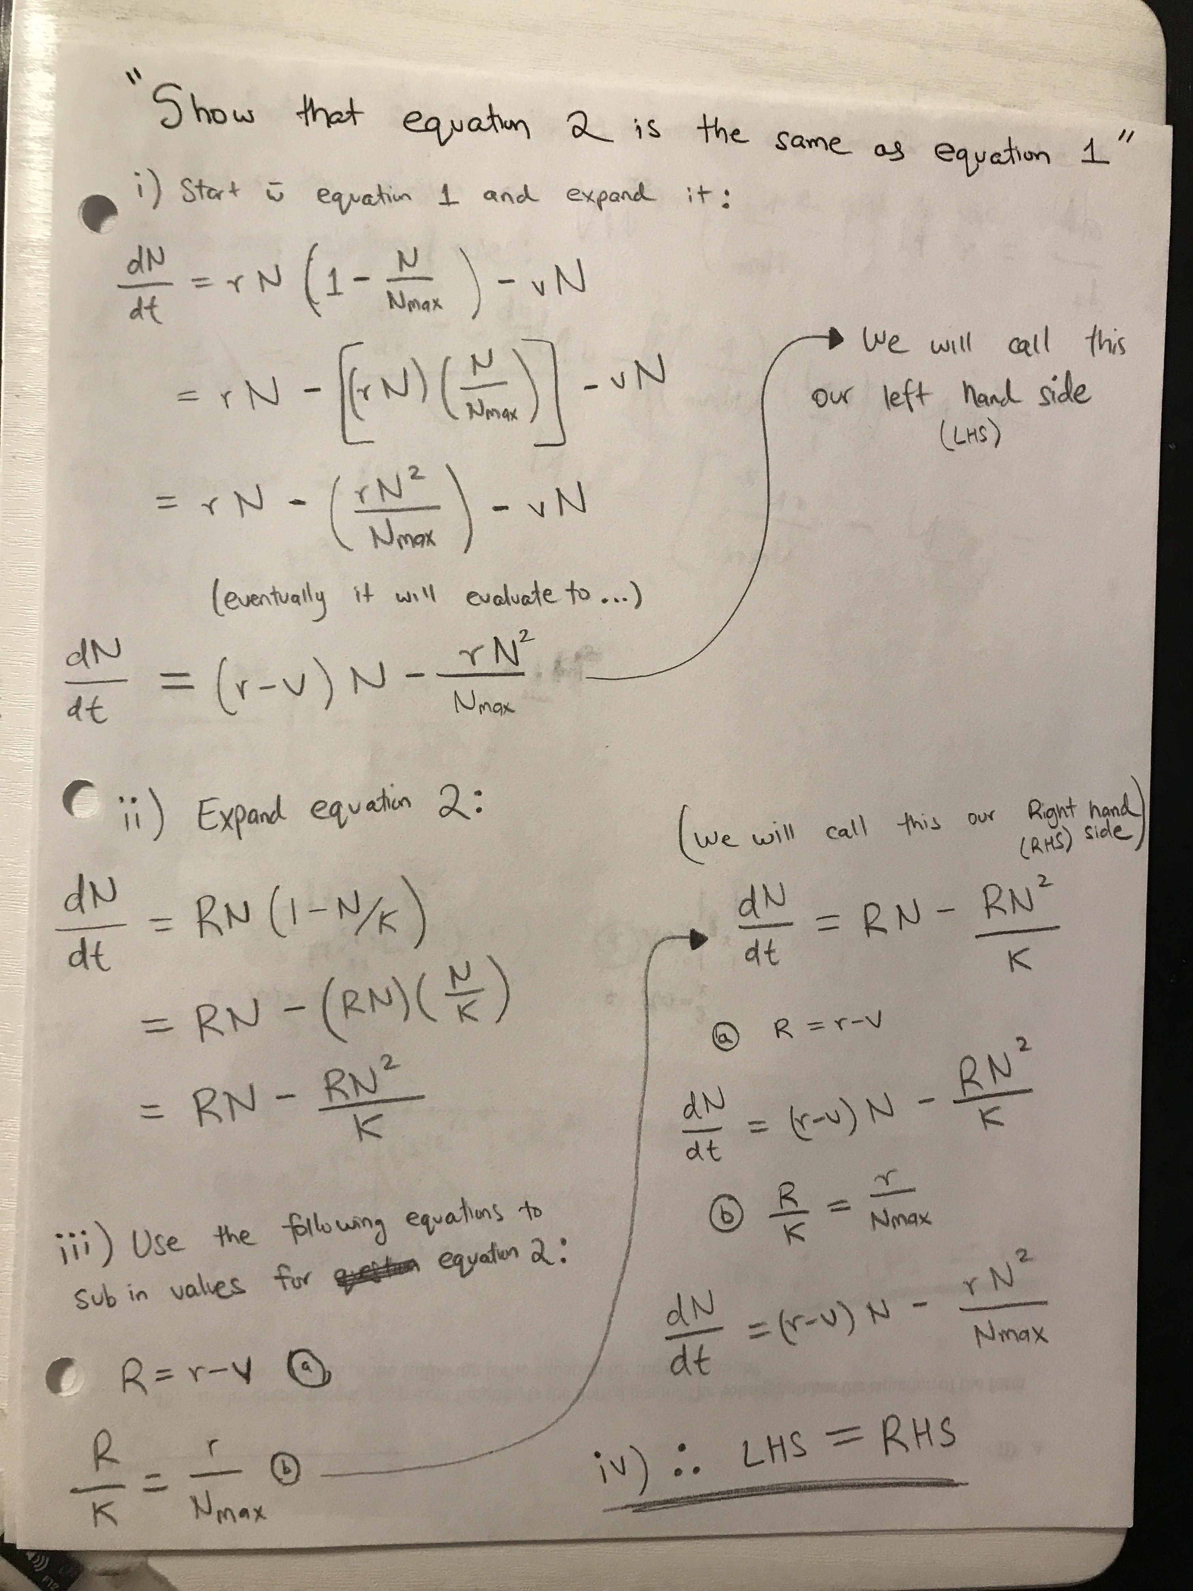

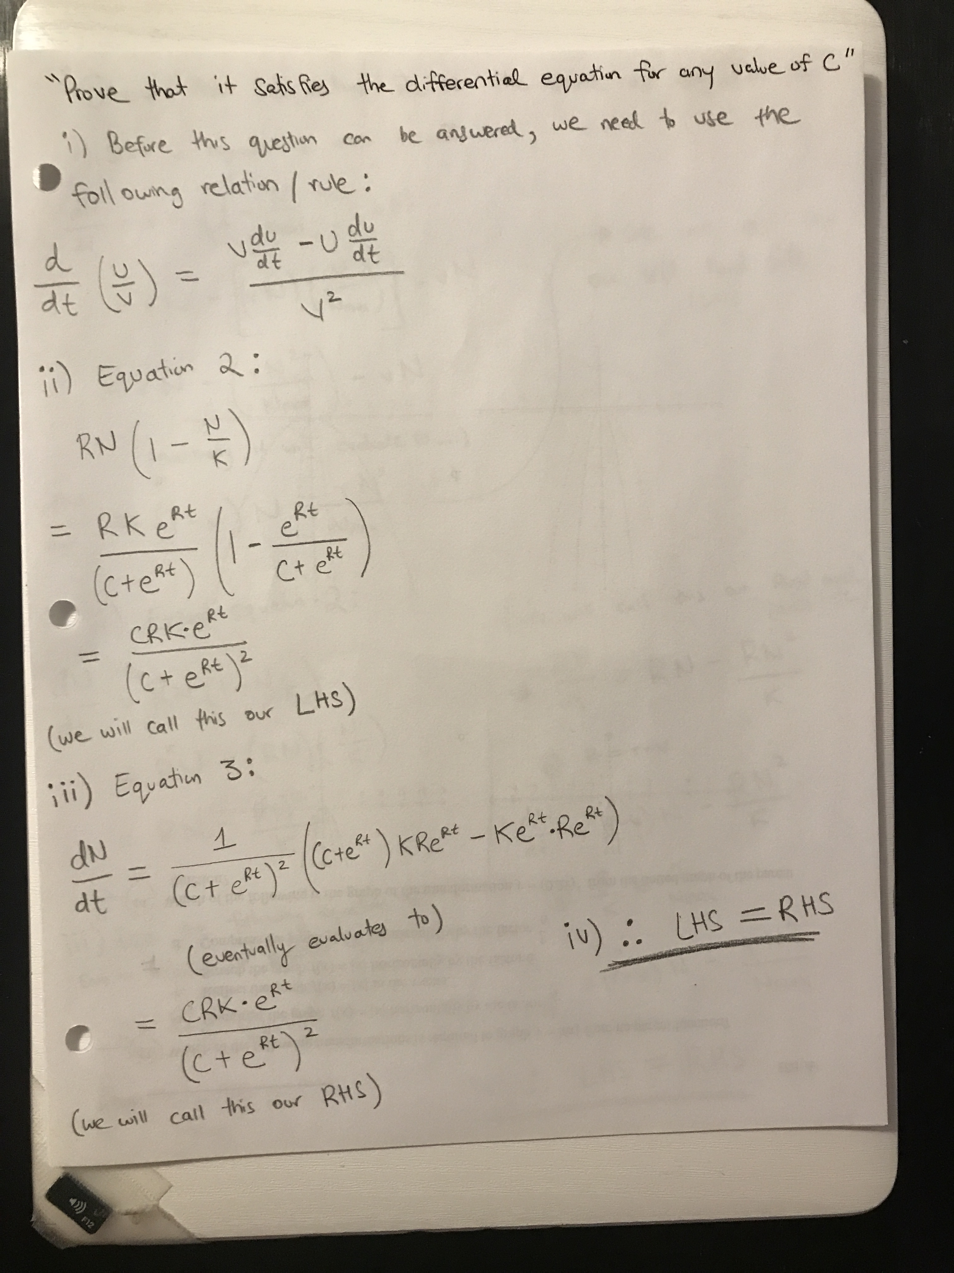

Question 3)
Note: The simulation was automatically terminated after 1000 ticks, similar to the exp-growth simulation. This was done to prevent an infinite simulation, which would cause the graph to extend far into the right side of the x-axis without presenting meaningful data; since populations are capped to the size of the lattice.
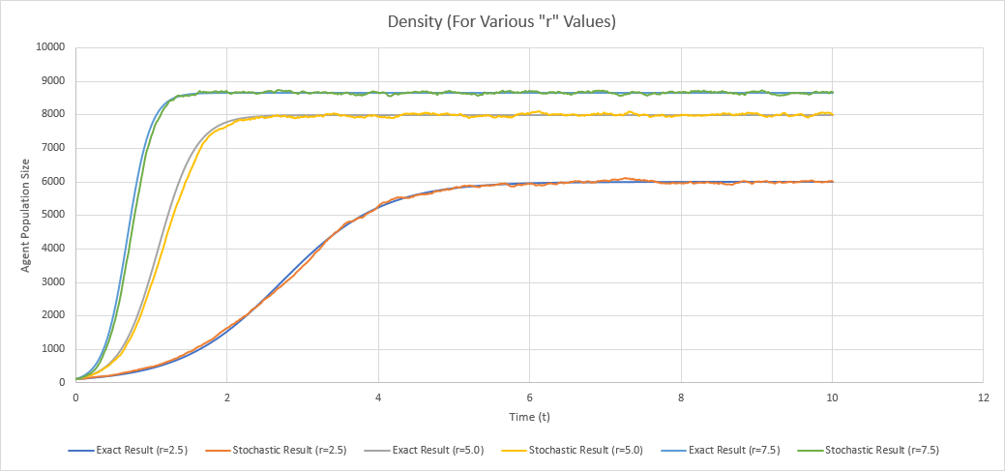Figure 4: This graph represents the agent population for when r=2.5, 5.0, and 7.5. The stochastic result and exact result are plotted on this graph; please refer to the legend for more information. In total, there are 6 lines/curves.

Question 4)
Figure 5: This graph plots spatial and logistic growth for various "r" values; r = 2.5, 5.0, and 7.5. The spatial model is the stochastic result and the logistic model is the exact result. In total, 6 lines/curves are present; 3 for each model.
The spatial model and the logistic model are very different. For instance, the spatial model grows more slowly and reaches a population size that is smaller than the carrying capacity, K, of the logistic model. This discrepancy can be explained due to the distribution of the (green) turtles in the spatial model. In the logistic model, a turtle can have (or hatch) a child (i.e. Another turtle) on any place on the lattice, provided it is not occupied by another turtle. As a result, the logistic model causes the population to explode because there is no limiting factor, other than the size of the lattice – which is the size of the carrying capacity. In contrast, in the spatial model, the turtles are restricted to sprouting (or hatching) near the parent (i.e. Neighboring patches). In total, there are only 8 patches a turtle can sprout on. As a result, this limitation puts a severe cap on how many children (i.e. Turtles) an agent can have. The lattice in NetLogo models this exactly. In the spatial growth model, we can see that agent populations are clustered. There are areas in the lattice with lots of turtles, and areas with no turtles. Please refer to the image below for more information.
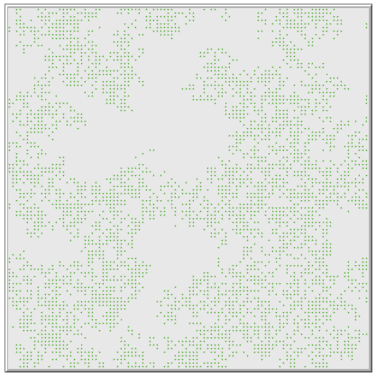Figure 6: This lattice represents spatial growth when r=2.5. Populations tend to cluster where they start which leaves lots of areas as sparsely populated. Hence, the spatial model grows more slowly than the logistic model.

Question 5)
According to the graph, see below, there is no minimum reproduction rate, r, at which the population can survive. This is because the latter part of the logisitic model will always be less than 1. The value can be very close to 1.0, but it will never be exactly 1.0. As a result, the population will always decrease, regardless of the value of 'r'. However, the greater the 'r' value, the slower the extinction rate. Nonetheless, extinction for the species will still occur due to the reproduction rate being lower than 1.0. Refer to graph below.
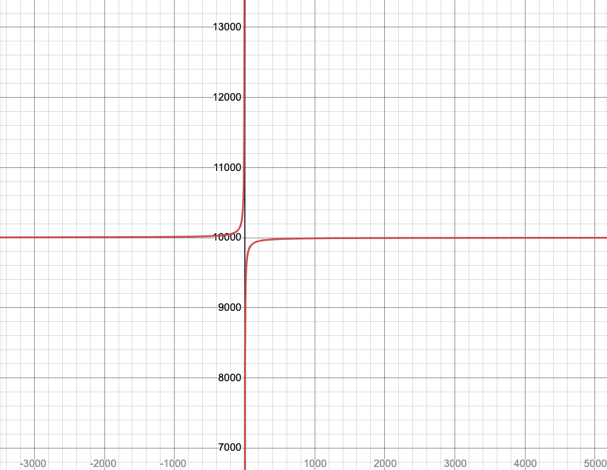Figure 7: Graphs the equation: K = N_max * ((r - v) / r), where `N_max` is 10000 and `v` is 1.

In the spatial model, the minimum value of "r" at which the population can survive is greater than 1.0. This is because a value of 1.0 or less will be lower than "v", which is the death rate. Put simply, the value of "r" needs to be greater than "v". Since the value of "v" is 1.0, "r" needs to be greater than 1.0. In fact, as long as the following equality holds, r – v > 1, then the population will survive.
The minimum value of "r" differs for both the spatial model and logistic model because the equations that model them are different. In the logistic model, a turtle can hatch anywhere on the lattice. In contrast, in the spatial model a turtle can only sprout (i.e. Hatch) near the parent's neigboring patches. Furthermore, this results in the vastly different population distributions we see in NetLogo when simulations are executed for both the spatial model and logisitic model.

Question 6)


